Celebrate the Women who Have Made a Difference in Your Life on Mother’s Day, May 10th
Mother’s Day is the perfect opportunity to honor the women who have made a lasting difference in your life. This Mother’s Day, please consider making a gift in support of the Women’s Foundation of Greater St. Louis to celebrate the women who have helped to shape you– perhaps your mother, wife, partner, daughter, sister, aunt, mentor or friend.
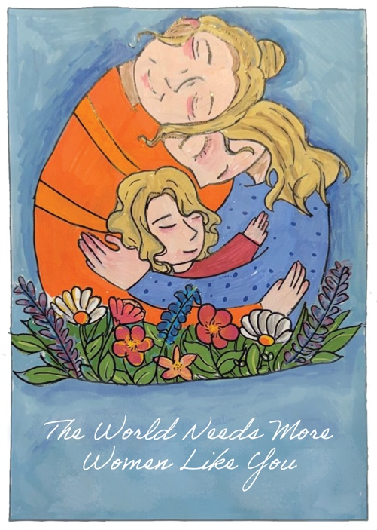

When you make a gift of $25 or more, WFSTL will send this card to your honoree, acknowledging your kindness, just in time for Mother’s Day.*

This year’s card was designed exclusively for the WFSTL by a local 7th grade student.

All proceeds will benefit WFSTL’s efforts to eliminate the barriers to economic independence for women in our region through grantmaking, education, building meaningful connections among advocates and service providers, and workplace and public policy advocacy.

Complete and return this form, scan the QR code below, or visit wfstl.org
*Please make your Mother’s Day gift by May 4.

Donor Name _______________________________________________________________________
Address _______________________________________________________________________
Payment
Check enclosed (make payable to the Women’s Foundation of Greater St. Louis)
Credit Card (circle one)
Visa MC Discover AmEx
Card Number ________________________________________________________________________
Exp date __________________ Sec Code ______________
Please charge my card for $____________________________ for _______ (number) tribute cards.

PLEASE MAIL TO:*
Name ______________________________________________________________________________
Address ______________________________________________________________________________
City, State, Zip ____________________________________________________________________________

*Additional names and contact information can be added to the back of this form
Return form and payment to: WFSTL | 8816 Manchester Road, #286, St. Louis, MO 63144

